## Create a Microsoft Dataverse table

## Create a custom table

Sign in to [Power Apps](https://make.powerapps.com/) and follow these steps to create a new custom table.

1. In the left navigation pane, expand **Data**, select **Tables**, and then select **+ New table**.
2. Under New table, enter the following:
   * **Display name**: Pet
3. In the Primary Column section, enter the following:
   * **Display name**: Pet Name
4. At the bottom, click **Create**.

**Add and customize columns**

1. In the list of Tables, select the **Pet** table that you created in the previous section.
2. On the **Columns** tab, on the table designer toolbar, select **Add column**.
3. In the **Column properties** pane, enter the following values:
   * **Display name**: *Species*
   * **Data type**: *Choice*
   * **Choice set**: *+ New choice*
   * **Searchable**: *Yes*
4. Create the choice set:
   * Replace *New choice* with *Dog*.
   * Select **Add new item**.
   * Replace *New choice* with *Cat*.
   * Select **Save**.

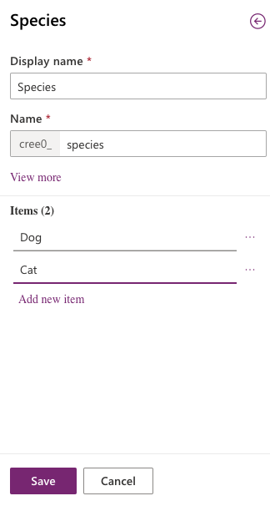

1. Make sure **Searchable** is selected, and then select **Done**.
2. On the table designer toolbar, select **Add column**.
3. In the **Column properties** pane, enter the following values, and then select **Done**:
   * **Display name**: *Breed*
   * **Data type**: *Text*
   * **Searchable**: *Yes*
4. On the table designer toolbar, select **Add column**.
5. In the **Column properties** pane, enter the following values, and then select **Done**:
   * **Display name**: *Appointment date*
   * **Data type**: *Date and Time*
   * **Searchable**: *Yes*
6. Select **Save table**.

**Add a relationship**

1. On the **Relationships** tab, on the table designer toolbar, select **Add relationship**, and then select **Many-to-one**.
2. In the right pane, in the **Related** list, select **Account**.
3. Select **Done**.
4. Select **Save table**.

Notice that when you add a many-to-one relationship, an **Account** column of the **Lookup** data type is automatically added to your list of columns on the **Columns** tab.

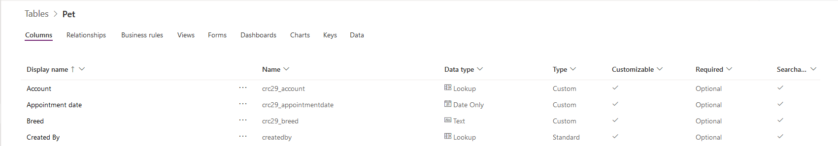

**Customize a view**

1. On the **Views** tab, right-click **Active Pets** view and select **Open Link in New Tab**. If you don't see the **Active Pets** view, select **Remove filter**.
2. In the view designer, select **+ View Column**, select the following columns, and then select **OK**:
   * Account
   * Appointment date
   * Breed
   * Species
3. Select the **Created On** column, select **Remove**.
4. To arrange the columns, select the column to move, and then select **Move Left** or **Move Right** until your view looks like this. You could also simply drag and drop the columns to arrange the order as well.

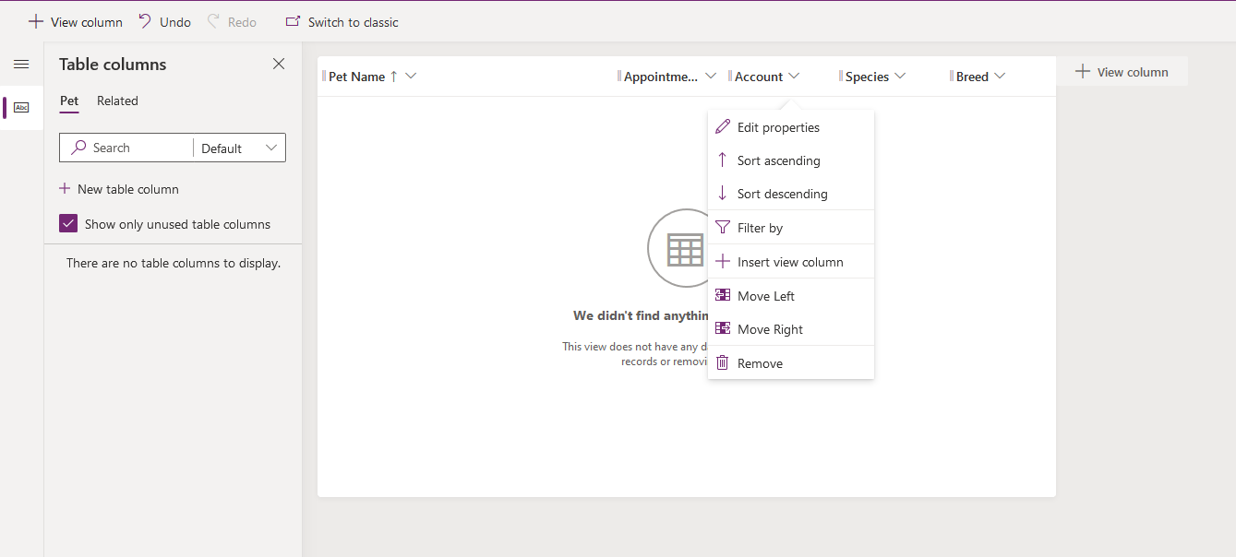

1. On the view designer toolbar, select **Save**.
2. Select **Publish**.

**Customize the main form**

1. In the left navigation pane, expand **Data**, select **Tables**, and then select **Pet**.
2. On the **Forms** tab, select **Information** next to the **Main** form type to open the form editor.

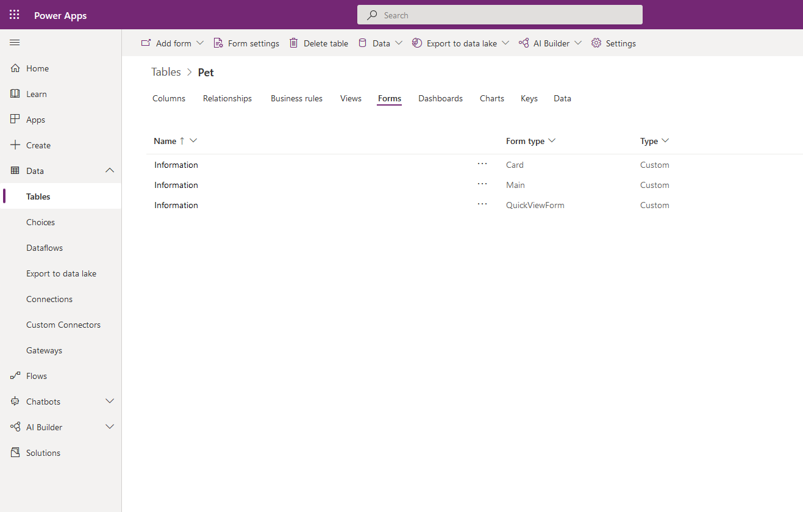

1. In the form editor, drag the **Species**, **Breed**, **Appointment date**, and **Account** columns from the **Column Explorer** pane to the **General** section of the form canvas, so that the form looks like this.

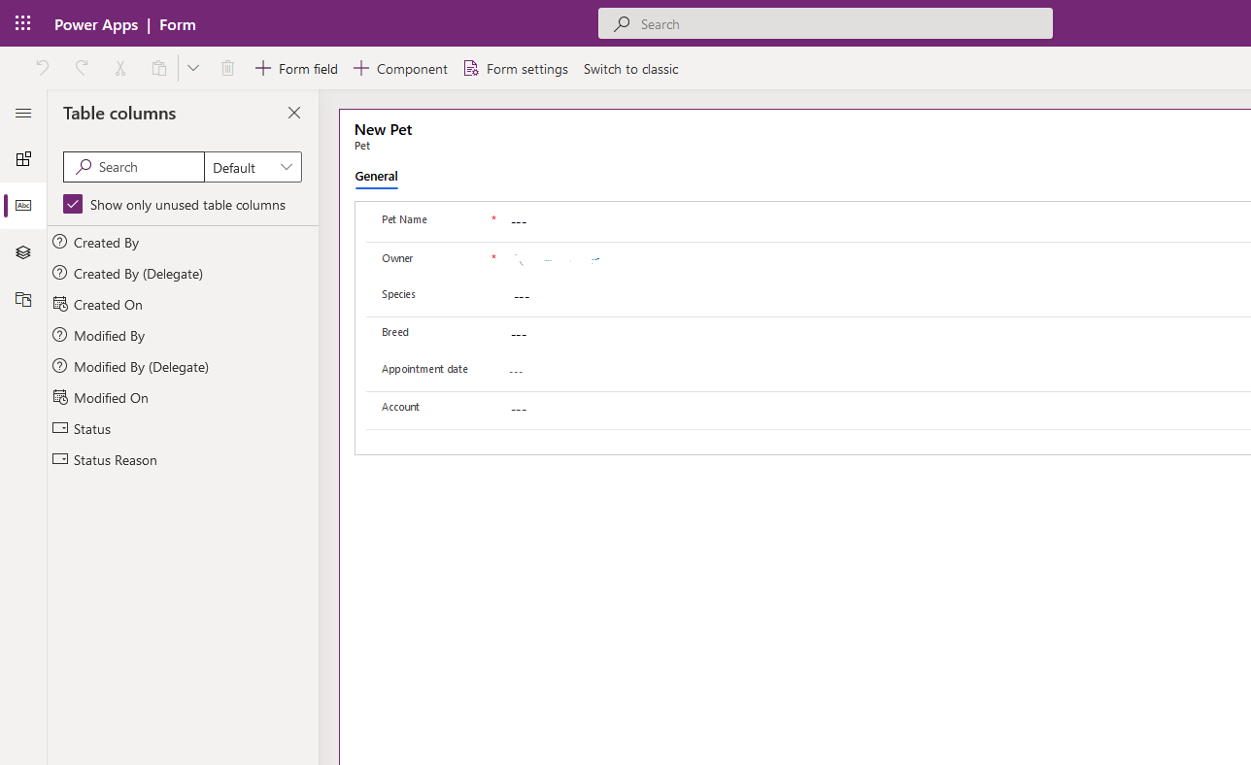

1. Select **Save**.
2. Select **Publish**.
3. Click the back arrow in your browser to close the form designer.